LINUX ASSIGNMENT 10

- xargs – Build and Execute Command Lines

- What is xargs?
  - xargs is basically a helper command in Linux that takes input (usually coming from another command through a pipe) and then turns that input into arguments for another command.
It’s very useful when you want to pass a long list of files or strings to a command that doesn’t accept piped input directly.

- Why do we use xargs?
  - There are two main reasons why we use xargs:
  - Some commands don’t accept input through pipes.
  - Even if they do, they might fail if there are too many arguments (like thousands of file names).
  - In such cases, xargs takes the input and feeds it to the command in small chunks, so everything works smoothly.

- How does xargs work?
  - It waits for some input → breaks it into items (words or lines) → and then runs a command on those items.

  - For e.g.) echo "apple banana mango" | xargs echo

  - #This will simply print:
apple banana mango
because xargs passed those words to echo.
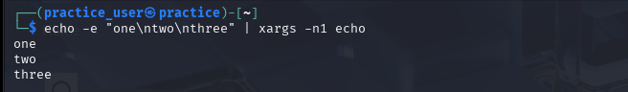
- 3) Option Flags for xargs (with actual command to run)
  - Here are some commonly used options for xargs:
  - -n <number> → run the command for this many arguments at a time
  - -p → ask before running each command
  - -t → show the command before executing it
  - -0 → read null-terminated input (useful with find -print0)
  - -I {} → replace {} with the input item
  - -d → specify a custom delimiter
  - -r → do not run command if input is empty.
- 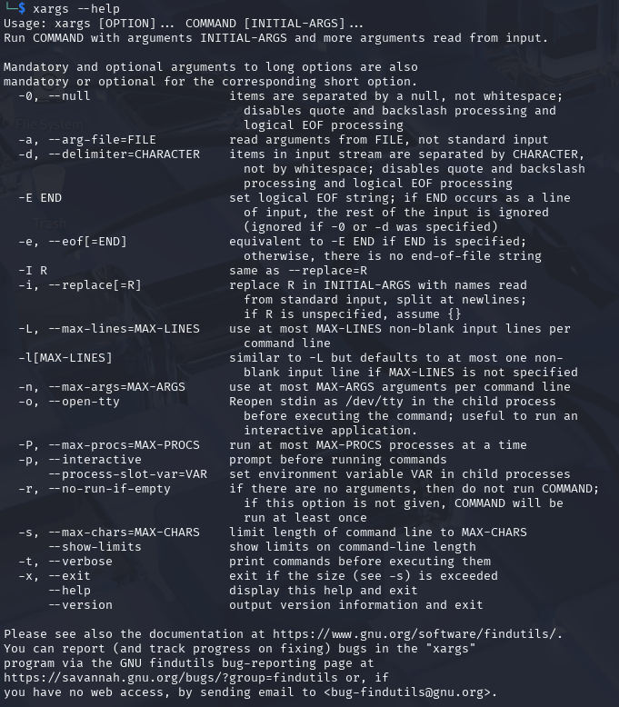

- 4) History of xargs
  - xargs has been around for quite a long time. It came with early UNIX systems in the late 1970s and early 1980s (mainly in System V and BSD). The main reason it was created was to solve the “argument list too long” problem that used to happen when you tried to pass thousands of files to a command.
  - Later it was added to the POSIX standard, which is why every Linux system today includes xargs by default.

- Composer – PHP Package Manager
- What is Composer?
  - Composer is the main package manager used in PHP. It helps in installing libraries or frameworks that our PHP project needs. Instead of downloading everything manually, Composer downloads and manages it automatically.

- Why do we need Composer?
  - It keeps track of all libraries used in a project
  - It handles version compatibility
  - It updates packages easily
  - It avoids manual copying of PHP files
  - It creates an autoloader so we don’t have to include every file manually
  - Basically, it makes PHP development much cleaner and more organised.

- How does Composer work?
  - You tell Composer which packages you want by creating a composer.json file or by using the require command. Composer then downloads all those packages into a folder called vendor.
  - E.g.) composer require monolog/monolog
  - #This command installs a logging library named Monolog.

- Option Flags (with real command to run)
  - Some important Composer commands:
  - composer install → installs dependencies from composer.lock
  - composer update → updates all dependencies
  - composer require package → installs a package
  - composer remove package → removes a package
  - composer show → shows installed packages
  - composer dump-autoload → regenerates Composer’s autoloader

- History of Composer
  - Composer was created around 2011 by Nils Adermann and Jordi Boggiano. They were inspired by package managers like npm (Node.js) and Bundler (Ruby).
  - Before Composer, PHP developers relied on manually downloading libraries, which was messy. Composer changed this completely and became the standard tool for PHP dependency management.
  - Packagist.org was created as the main repository for Composer packages, and now almost every modern PHP project uses Composer.

